FILE OPERATIONS(CONT..)
From operational point of view, a user should be able to create a file
We will considered him/her as owner of the file.
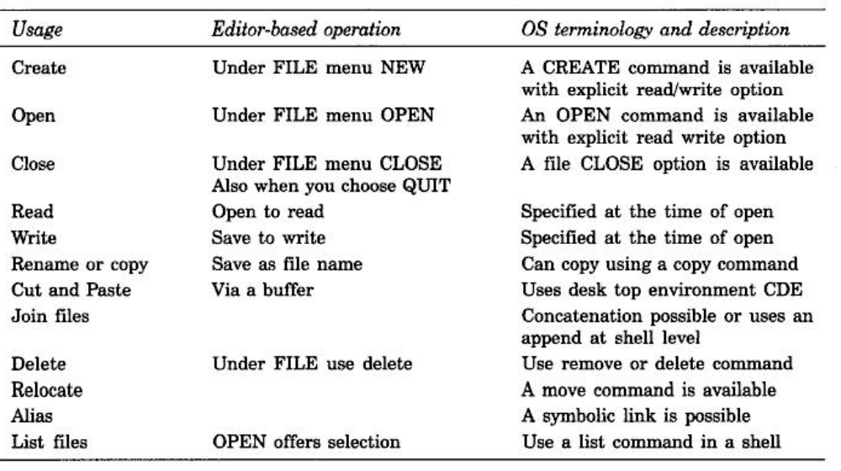
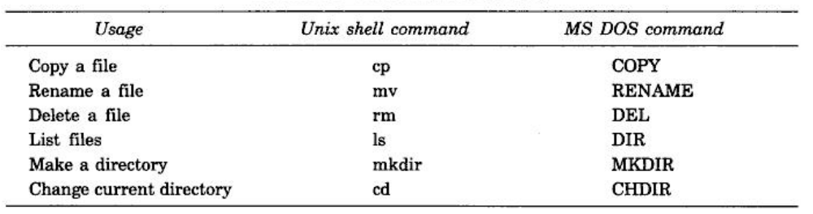
FILEACCESSANDSECURITY
In Unix, owner of a file can change its permissions using chmodcommand which has a syntax as follows:
chmodpattern fileNameas in chmod644 myFile
e.g: 644 corresponds to the pattern rw-r--r--
664 corresponds to the patternrw-rw—r--
ls–l command displays the access permissions of a file.

Unix internally recognizes 4 different file types
(1)ordinary(2) directory(3) special and (4)named.

Inodestructure is used by Unix to maintain information about the named files.

A QUEUINGMODEL
Data structures are used for process management.
OS maintains a queue for all ready-to-run processes.

OS may have separate queue for each of the likely events (including completion of IO). 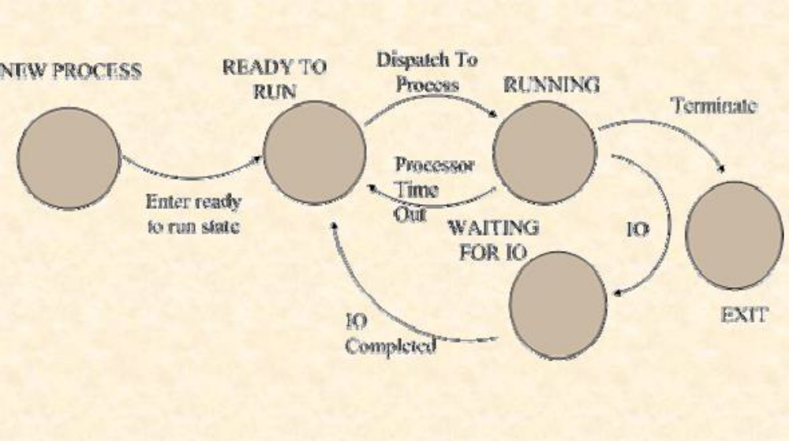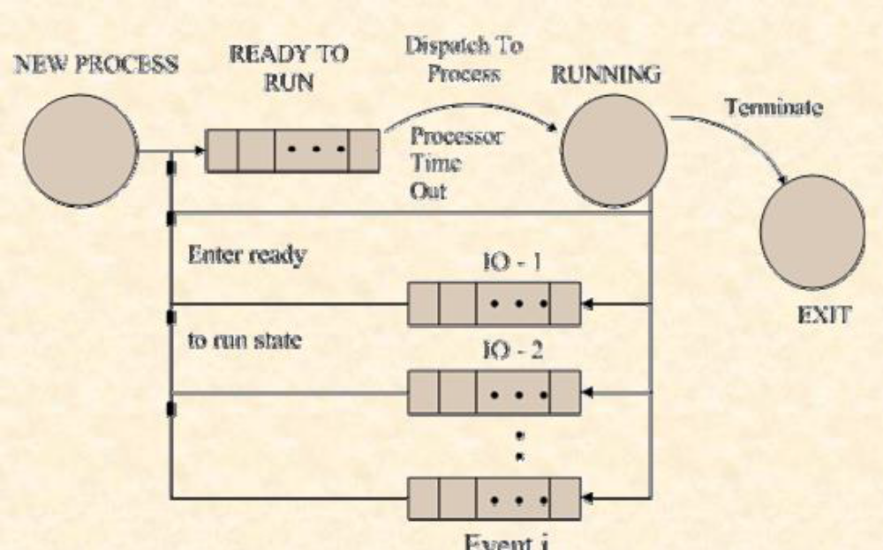

TYPESOFSCHEDULER
Short term scheduler(CPU scheduler)

Selects from among the processes that are ready to execute, & allocates the CPU to one of them.
Long term scheduler(job scheduler)

Selects processes from pool which are spooled to mass storage device & loads them in memory for execution.
Medium term scheduler

Reduces process from memory & then re-introduce memory with continuing its execution where it was left by technique of swapping.

Response Time
Premptive
Non Premptive Scheduling
Context Switching
Relocation Register
Fifo Page replacement
Page Fault
Segmentation
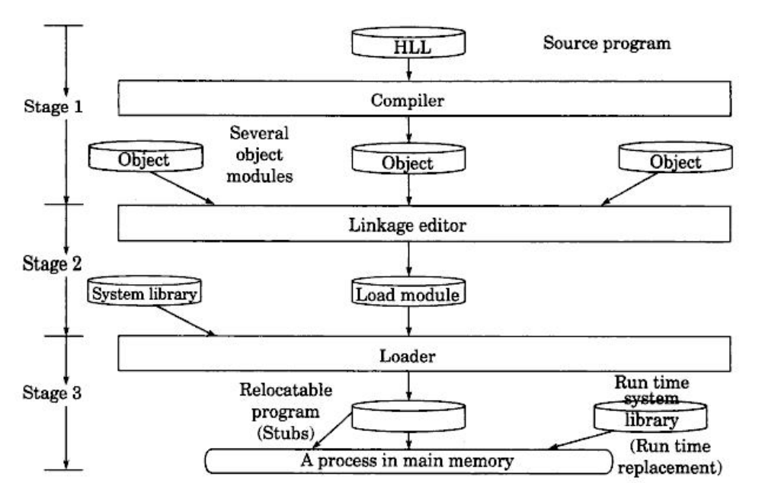

Paging
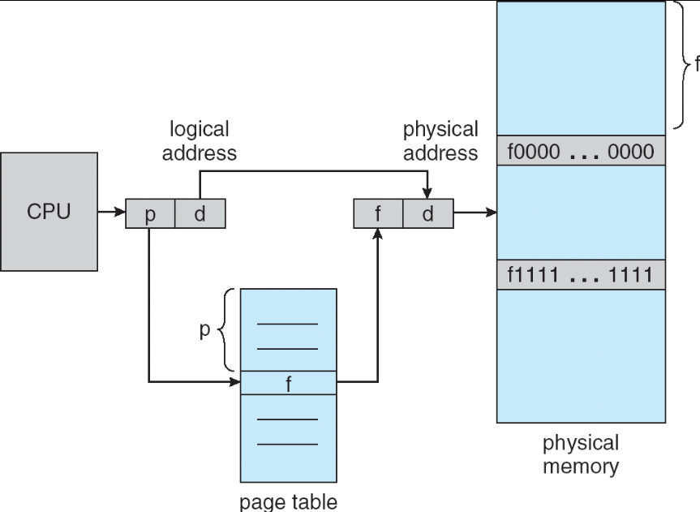
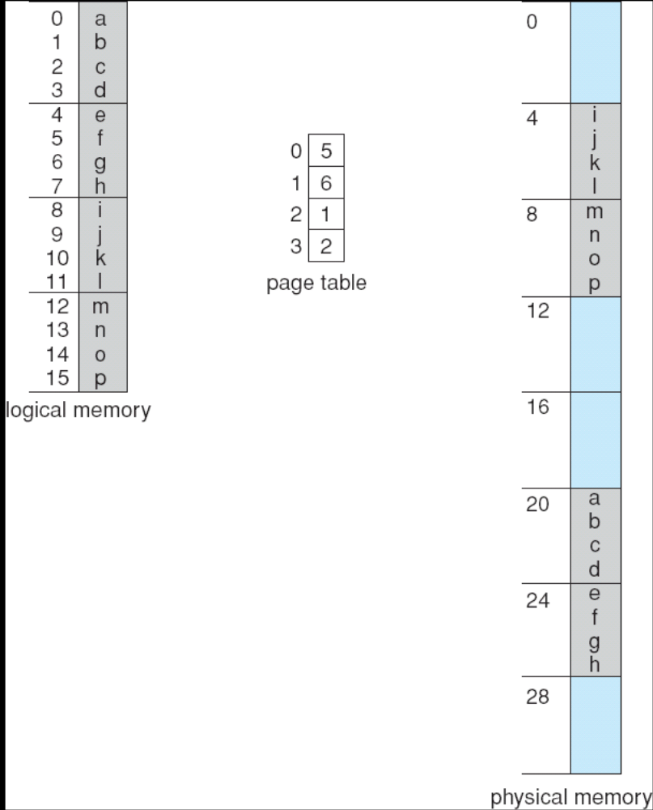
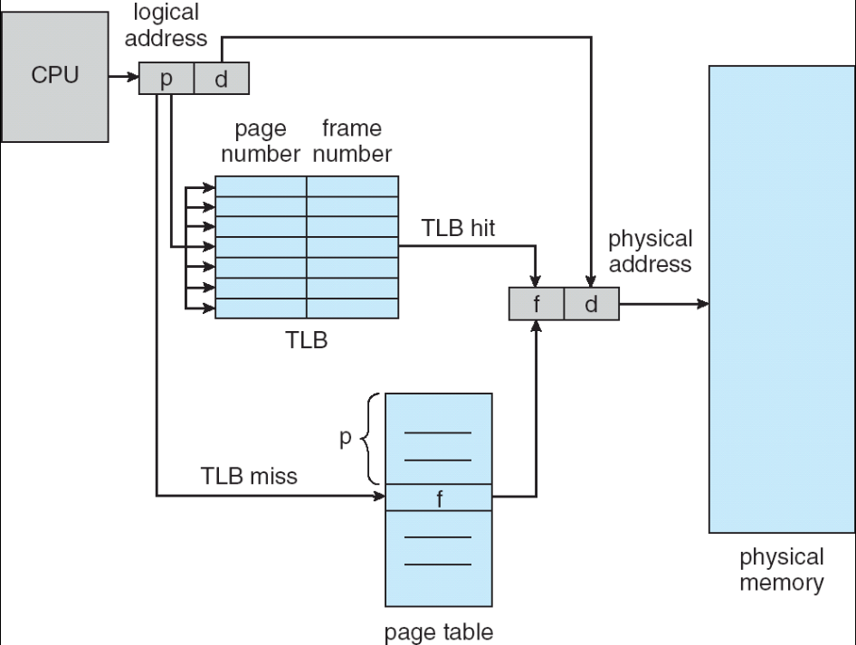
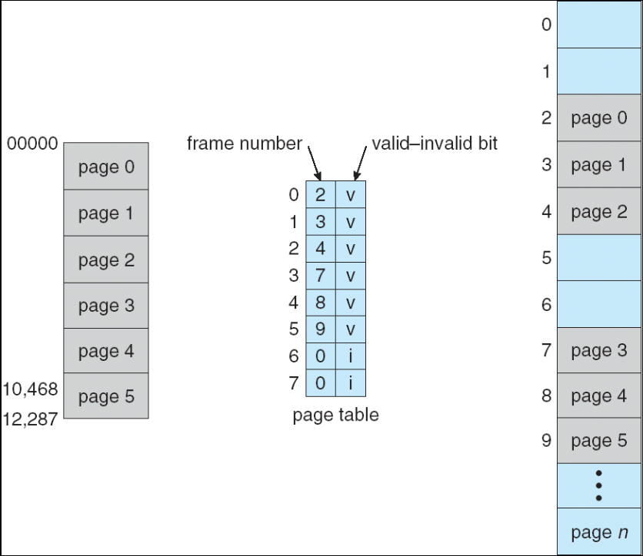

Page Fault
